Pyramid-Based Subtraction

Definition
# Source: AI Source: Provided by: [Data Path: Persons Table -> ID Column: 1, Name_En Column: Motasem Essam] -> From: [ChatGPT] on [7/25/2026]
Pyramid-Based Subtraction is a type of composite solid formation in which one or more geometric portions are removed from an original pyramid or a pyramid-based solid to create cavities, holes, notches, grooves, slots, or other cutout shapes.
The removed portions may be pyramids, prisms, cylinders, cones, spheres, or other geometric solids.
The resulting object is called a pyramid-based solid formed by subtraction.

Simple Definition
# Source: AI Source: Provided by: [Data Path: Persons Table -> ID Column: 1, Name_En Column: Motasem Essam] -> From: [ChatGPT] on [7/25/2026]
Pyramid-Based Subtraction means removing one or more geometric portions from a pyramid-shaped solid to create a new three-dimensional shape.
Example: Removing a smaller square pyramid from the center of a larger square pyramid to create a pyramidal cavity.

Geometric Representation
# Source: AI Source: Provided by: [Data Path: Persons Table -> ID Column: 1, Name_En Column: Motasem Essam] -> From: [ChatGPT] on [7/25/2026]
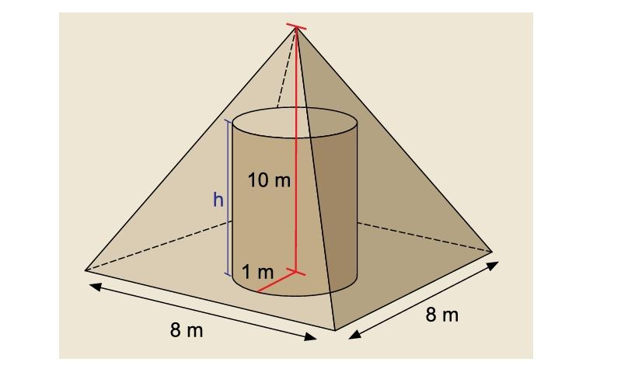
Main Components
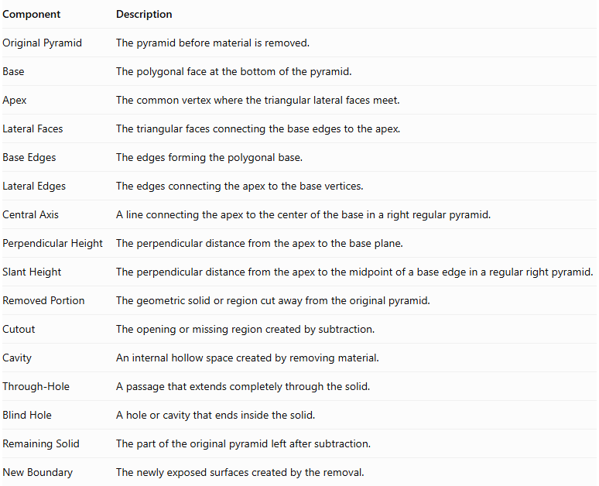
Component | Description
Original Pyramid | The pyramid before material is removed.
Base | The polygonal face at the bottom of the pyramid.
Apex | The common vertex where the triangular lateral faces meet.
Lateral Faces | The triangular faces connecting the base edges to the apex.
Base Edges | The edges forming the polygonal base.
Lateral Edges | The edges connecting the apex to the base vertices.
Central Axis | A line connecting the apex to the center of the base in a right regular pyramid.
Perpendicular Height | The perpendicular distance from the apex to the base plane.
Slant Height | The perpendicular distance from the apex to the midpoint of a base edge in a regular right pyramid.
Removed Portion | The geometric solid or region cut away from the original pyramid.
Cutout | The opening or missing region created by subtraction.
Cavity | An internal hollow space created by removing material.
Through-Hole | A passage that extends completely through the solid.
Blind Hole | A hole or cavity that ends inside the solid.
Remaining Solid | The part of the original pyramid left after subtraction.
New Boundary | The newly exposed surfaces created by the removal.

Types of Pyramid-Based Subtraction

Pyramidal Subtraction from a Pyramid
# Source: AI Source: Provided by: [Data Path: Persons Table -> ID Column: 1, Name_En Column: Motasem Essam] -> From: [ChatGPT] on [7/25/2026]
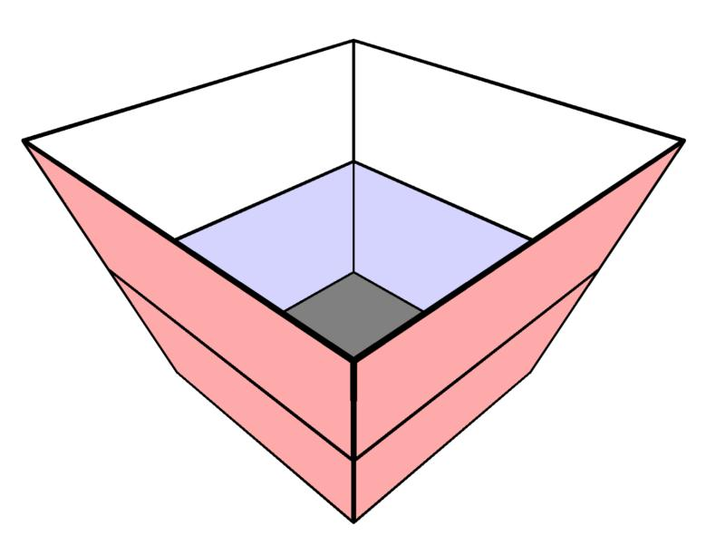
A smaller pyramid-shaped portion is removed from a larger pyramid.
Examples:
- Square pyramidal cavity.
- Triangular pyramidal cavity.
- Pentagonal pyramidal cavity.
- Hexagonal pyramidal cavity.
- Central pyramidal cavity.
- Off-center pyramidal cavity.
- Inverted pyramidal cavity.

Cylindrical Subtraction from a Pyramid
# Source: AI Source: Provided by: [Data Path: Persons Table -> ID Column: 1, Name_En Column: Motasem Essam] -> From: [ChatGPT] on [7/25/2026]
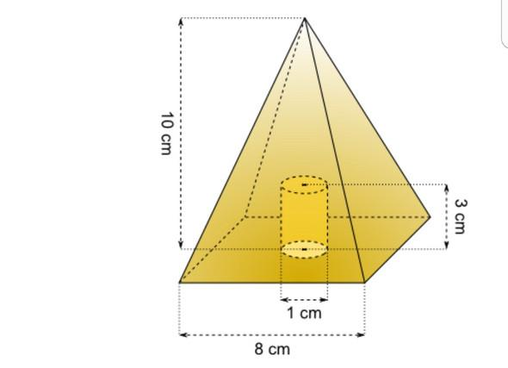
A cylindrical portion is removed from a pyramid.
Examples:
- Central cylindrical hole.
- Off-center cylindrical hole.
- Vertical cylindrical cavity.
- Horizontal cylindrical tunnel.
- Cylindrical blind hole.
- Cylindrical through-hole.

Conical Subtraction from a Pyramid
# Source: AI Source: Provided by: [Data Path: Persons Table -> ID Column: 1, Name_En Column: Motasem Essam] -> From: [ChatGPT] on [7/25/2026]
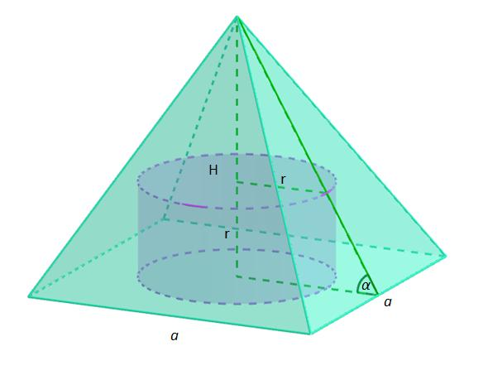
A conical portion is removed from a pyramid.
Examples:
- Central conical cavity.
- Off-center conical cavity.
- Conical through-hole.
- Conical blind cavity.
- Inverted conical cavity.

Rectangular Prism Subtraction from a Pyramid
# Source: AI Source: Provided by: [Data Path: Persons Table -> ID Column: 1, Name_En Column: Motasem Essam] -> From: [ChatGPT] on [7/25/2026]
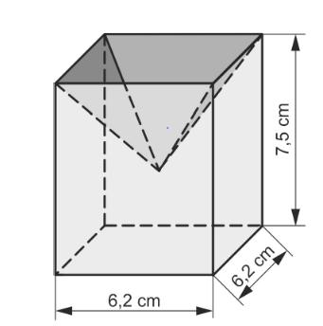
A rectangular-prism-shaped portion is removed from a pyramid.
Examples:
- Rectangular notch.
- Rectangular cavity.
- Rectangular slot.
- Rectangular side opening.
- Rectangular through-cut.

Triangular Prism Subtraction from a Pyramid
# Source: AI Source: Provided by: [Data Path: Persons Table -> ID Column: 1, Name_En Column: Motasem Essam] -> From: [ChatGPT] on [7/25/2026]
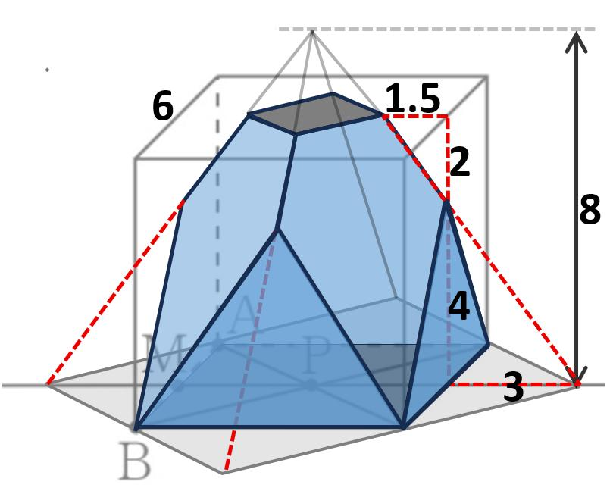
A triangular-prism-shaped portion is removed from a pyramid.
Examples:
- Triangular notch.
- Wedge-shaped cutout.
- Triangular cavity.
- Triangular side opening.
- Triangular through-cut.

Spherical Subtraction from a Pyramid
# Source: AI Source: Provided by: [Data Path: Persons Table -> ID Column: 1, Name_En Column: Motasem Essam] -> From: [ChatGPT] on [7/25/2026]
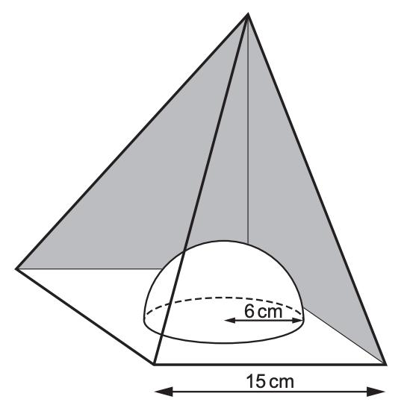
A spherical portion is removed from a pyramid.
Examples:
- Spherical cavity.
- Partial spherical depression.
- Spherical through-opening.
- Off-center spherical cutout.

Multiple-Shape Subtraction from a Pyramid
# Source: AI Source: Provided by: [Data Path: Persons Table -> ID Column: 1, Name_En Column: Motasem Essam] -> From: [ChatGPT] on [7/25/2026]
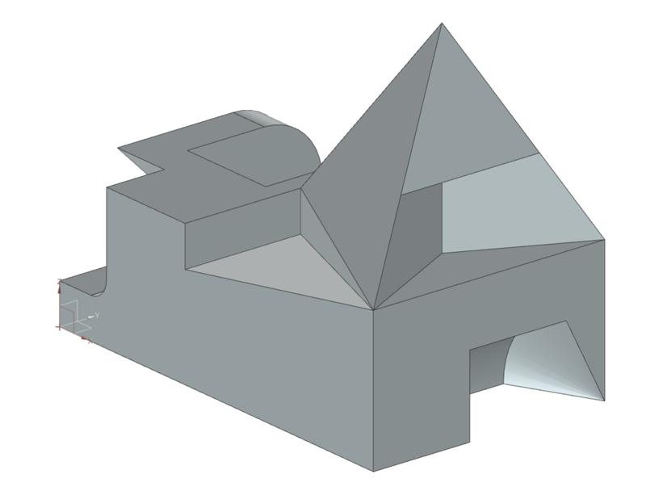
Two or more portions are removed from the same pyramid.
Examples:
- Multiple cylindrical holes.
- Pyramidal cavity with cylindrical hole.
- Rectangular notch with spherical cavity.
- Multiple mixed-shape cutouts.

Classification by Location of Subtraction
# Source: AI Source: Provided by: [Data Path: Persons Table -> ID Column: 1, Name_En Column: Motasem Essam] -> From: [ChatGPT] on [7/25/2026]
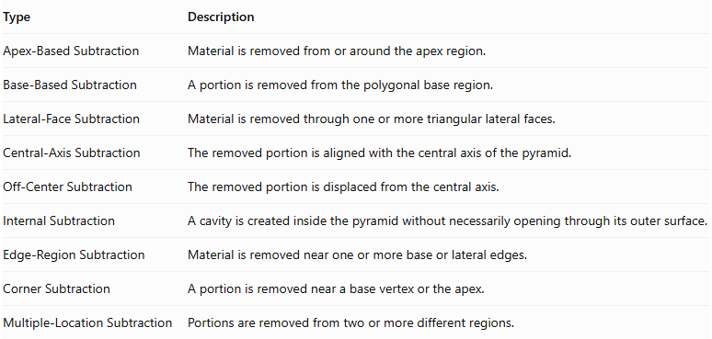
Type | Description
Apex-Based Subtraction | Material is removed from or around the apex region.
Base-Based Subtraction | A portion is removed from the polygonal base region.
Lateral-Face Subtraction | Material is removed through one or more triangular lateral faces.
Central-Axis Subtraction | The removed portion is aligned with the central axis of the pyramid.
Off-Center Subtraction | The removed portion is displaced from the central axis.
Internal Subtraction | A cavity is created inside the pyramid without necessarily opening through its outer surface.
Edge-Region Subtraction | Material is removed near one or more base or lateral edges.
Corner Subtraction | A portion is removed near a base vertex or the apex.
Multiple-Location Subtraction | Portions are removed from two or more different regions.

Classification by Subtraction Method
# Source: AI Source: Provided by: [Data Path: Persons Table -> ID Column: 1, Name_En Column: Motasem Essam] -> From: [ChatGPT] on [7/25/2026]
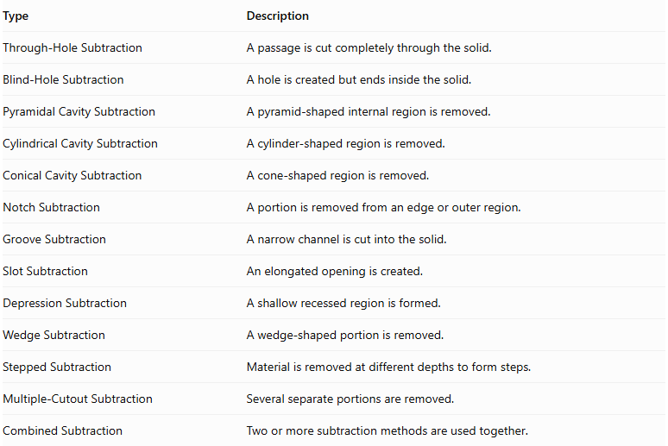
Type | Description
Through-Hole Subtraction | A passage is cut completely through the solid.
Blind-Hole Subtraction | A hole is created but ends inside the solid.
Pyramidal Cavity Subtraction | A pyramid-shaped internal region is removed.
Cylindrical Cavity Subtraction | A cylinder-shaped region is removed.
Conical Cavity Subtraction | A cone-shaped region is removed.
Notch Subtraction | A portion is removed from an edge or outer region.
Groove Subtraction | A narrow channel is cut into the solid.
Slot Subtraction | An elongated opening is created.
Depression Subtraction | A shallow recessed region is formed.
Wedge Subtraction | A wedge-shaped portion is removed.
Stepped Subtraction | Material is removed at different depths to form steps.
Multiple-Cutout Subtraction | Several separate portions are removed.
Combined Subtraction | Two or more subtraction methods are used together.

Classification by Number and Arrangement
# Source: AI Source: Provided by: [Data Path: Persons Table -> ID Column: 1, Name_En Column: Motasem Essam] -> From: [ChatGPT] on [7/25/2026]
- Single Subtraction: One portion is removed from the pyramid.
- Double Subtraction: Two portions are removed.
- Multiple Subtraction: Three or more portions are removed.
- Repeated Subtraction: Similar cutouts are repeated in different locations.
- Axial Subtraction: The removed portions are aligned with the pyramid's central axis.
- Radial Subtraction: Cutouts are arranged around the central axis.
- Symmetrical Subtraction: Removed portions are arranged symmetrically.
- Asymmetrical Subtraction: Removed portions are arranged without symmetry.
- Uniform Subtraction: Repeated cutouts have consistent dimensions and spacing.
- Non-Uniform Subtraction: Cutouts differ in dimensions or spacing.
- Mixed-Shape Subtraction: Different geometric shapes are removed from the same pyramid.

Mathematical Properties and Formulas

Volume of the Original Pyramid
# Source: AI Source: Provided by: [Data Path: Persons Table -> ID Column: 1, Name_En Column: Motasem Essam] -> From: [ChatGPT] on [7/25/2026]
For any pyramid:
$$V_{pyramid}=\frac{1}{3}BH$$
Where:
- $B$ = area of the polygonal base.
- $H$ = perpendicular height from the apex to the base plane.
For a square pyramid with base side length $s$:
$$V=\frac{1}{3}s^{2}H$$
For a rectangular pyramid with base length $l$ and width $w$:
$$V=\frac{1}{3}lwH$$

Surface Area of a Regular Pyramid
# Source: AI Source: Provided by: [Data Path: Persons Table -> ID Column: 1, Name_En Column: Motasem Essam] -> From: [ChatGPT] on [7/25/2026]
For a regular pyramid:
$$SA=B+\frac{1}{2}Pl$$
Where:
- $B$ = base area.
- $P$ = perimeter of the base.
- $l$ = slant height, measured perpendicular to a base edge along a lateral face.
For a regular square pyramid:
$$SA=s^{2}+2sl$$
Its slant height is:
$$l=\sqrt{H^{2}+(\frac{s}{2})^{2}}$$
The lateral surface area is:
$$LSA=\frac{1}{2}Pl$$

Remaining Volume After Subtraction
# Source: AI Source: Provided by: [Data Path: Persons Table -> ID Column: 1, Name_En Column: Motasem Essam] -> From: [ChatGPT] on [7/25/2026]
$$V_{remaining}=V_{original}-V_{removed}$$
For multiple non-overlapping removed portions:
$$V_{remaining}=V_{original}-\sum_{i=1}^{n}{V_{i}}$$
If removed portions overlap, their intersections must not be subtracted more than once.

Volume of Common Removed Shapes
# Source: AI Source: Provided by: [Data Path: Persons Table -> ID Column: 1, Name_En Column: Motasem Essam] -> From: [ChatGPT] on [7/25/2026]
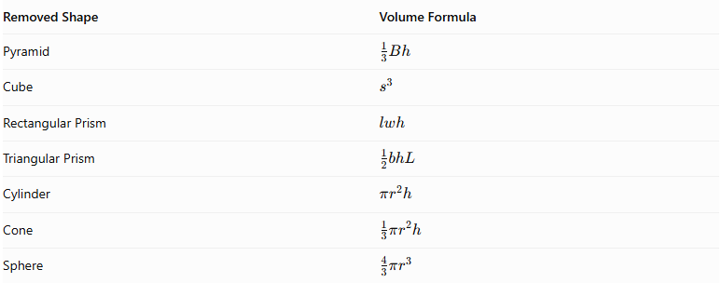
Removed Shape | Volume Formula
Pyramid | $$\frac{1}{3}Bh$$
Cube | $$s^{3}$$
Rectangular Prism | $$lwh$$
Triangular Prism | $$\frac{1}{2}bhL$$
Cylinder | $$πr^{2}h$$
Cone | $$\frac{1}{3}πr^{2}h$$
Sphere | $$\frac{4}{3}πr^{3}$$
Here, $B$ is the removed pyramid's base area, $h$ is its perpendicular height, and $L$ is a prism's length.

Surface Area After Subtraction
# Source: AI Source: Provided by: [Data Path: Persons Table -> ID Column: 1, Name_En Column: Motasem Essam] -> From: [ChatGPT] on [7/25/2026]
$${SA}_{remaining}={SA}_{original}-{SA}_{removed boundary}+{SA}_{newly exposed}$$
This means:
- Subtract the portions of the original external surface that become openings.
- Add the newly exposed surfaces inside the cavities or cutouts.
- Keep all original surfaces that remain exposed.
Important: The surface area of the removed solid is not automatically the surface area to subtract. The actual contact and intersection geometry determines the surface-area changes.

Worked Examples

Example 1: Square Pyramid with a Square Pyramidal Cavity
# Source: AI Source: Provided by: [Data Path: Persons Table -> ID Column: 1, Name_En Column: Motasem Essam] -> From: [ChatGPT] on [7/25/2026]
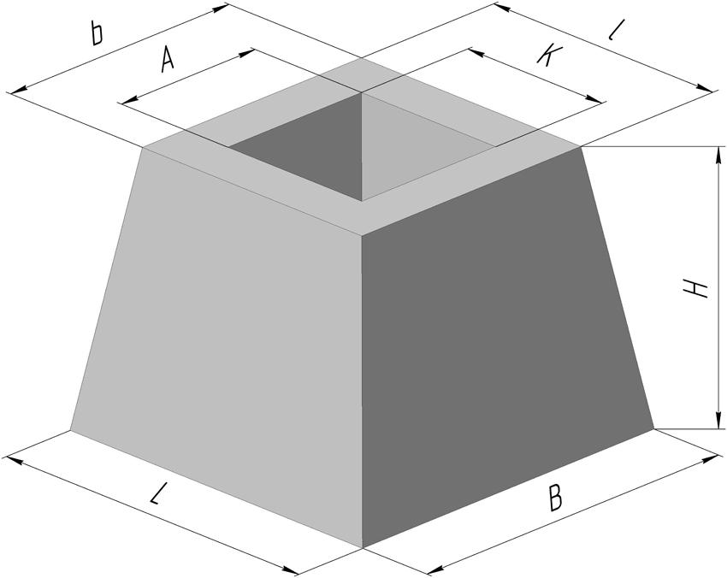
Given:
- Original square pyramid base side: $s=10 cm$
- Original perpendicular height: $H=12 cm$
- Removed square pyramid base side: $a=4 cm$
- Cavity depth: $d=6 cm$
The smaller square pyramid cavity opens through the original base and ends at an internal apex.
Step 1: Calculate the original pyramid volume.
$$V_{original}=\frac{1}{3}({10}^{2})(12)=400{ cm}^{3}$$
Step 2: Calculate the removed pyramid volume.
$$V_{removed}=\frac{1}{3}(4^{2})(6)=32{ cm}^{3}$$
Step 3: Calculate the remaining volume.
$$V_{remaining}=400-32$$
$$\boxed{V_{remaining}=368{ cm}^{3}}$$
Step 4: Calculate the original surface area.
The original slant height is:
$$l=\sqrt{{12}^{2}+5^{2}}=13$$
The original total surface area is:
$${SA}_{original}={10}^{2}+2(10)(13)=360{ cm}^{2}$$
Step 5: Calculate the cavity's slant height.
$$l_{c}=\sqrt{6^{2}+2^{2}}=\sqrt{40}=2\sqrt{10}$$
The cavity's lateral surface area is:
$${LSA}_{c}=\frac{1}{2}(16)(2\sqrt{10})=16\sqrt{10}$$
Step 6: Calculate the remaining surface area.
The square opening removes $4^{2}=16{ cm}^{2}$ from the original base. The cavity's four triangular faces become newly exposed.
$${SA}_{remaining}=360-16+16\sqrt{10}$$
$$\boxed{{SA}_{remaining}≈394.60{ cm}^{2}}$$
Conclusion: The pyramidal cavity reduces the volume and adds four new internal triangular surfaces.

Example 2: Square Pyramid with a Cylindrical Blind Hole
# Source: AI Source: Provided by: [Data Path: Persons Table -> ID Column: 1, Name_En Column: Motasem Essam] -> From: [ChatGPT] on [7/25/2026]
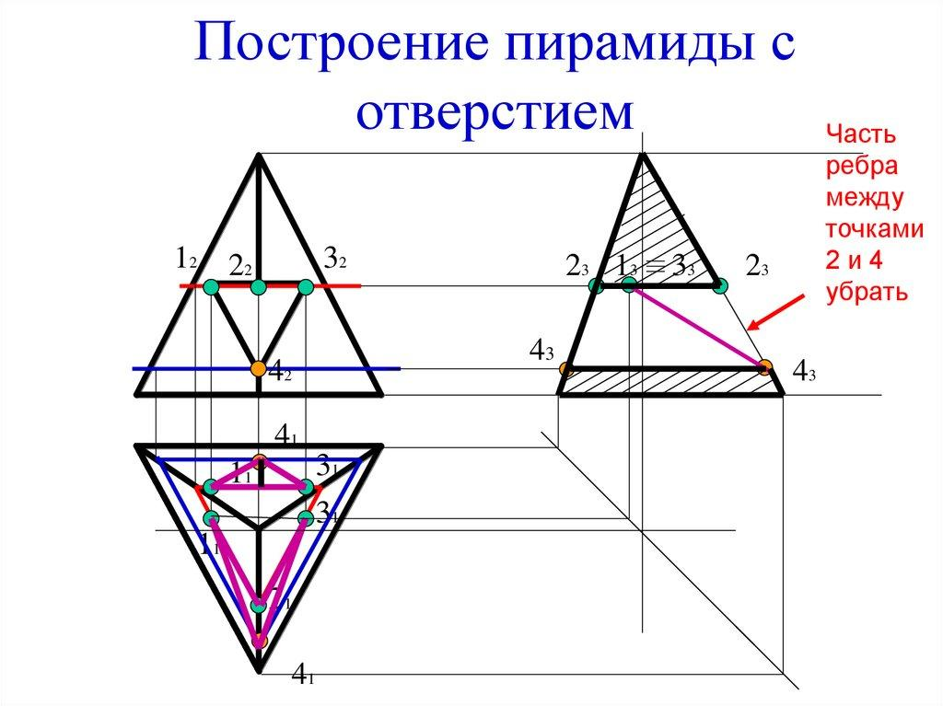
Given:
- Original square pyramid base side: $s=10 cm$
- Original perpendicular height: $H=12 cm$
- Cylindrical hole radius: $r=1 cm$
- Hole depth: $d=6 cm$
The cylindrical hole is centered on the pyramid's vertical axis and extends upward from the base. It ends inside the pyramid.
Step 1: Calculate the original pyramid volume.
$$V_{original}=\frac{1}{3}({10}^{2})(12)=400{ cm}^{3}$$
Step 2: Calculate the removed cylinder volume.
$$V_{removed}=π(1)^{2}(6)=6π{ cm}^{3}$$
Step 3: Calculate the remaining volume.
$$V_{remaining}=400-6π$$
$$\boxed{V_{remaining}≈381.15{ cm}^{3}}$$
Step 4: Calculate the original surface area.
$$l=\sqrt{{12}^{2}+5^{2}}=13$$
$${SA}_{original}=100+2(10)(13)=360{ cm}^{2}$$
Step 5: Calculate the new surface area.
The circular opening in the base and the circular bottom of the blind hole have equal areas, so these areas cancel.
The newly exposed cylindrical inner wall is:
$$A_{inner}=2πrd$$
$$A_{inner}=2π(1)(6)=12π$$
Therefore:
$${SA}_{remaining}=360+12π$$
$$\boxed{{SA}_{remaining}≈397.70{ cm}^{2}}$$
Conclusion: The cylindrical hole decreases the pyramid's volume and creates an internal curved surface.

Important Characteristics
# Source: AI Source: Provided by: [Data Path: Persons Table -> ID Column: 1, Name_En Column: Motasem Essam] -> From: [ChatGPT] on [7/25/2026]
- Pyramid-Based Structure: The original solid is a pyramid or a composite solid containing a pyramid.
- Material Removal: One or more geometric portions are removed.
- Volume Reduction: The remaining volume is smaller than the original volume.
- Surface Modification: New internal or external surfaces may appear after subtraction.
- Variable Cutout Shapes: Removed portions can be pyramidal, cylindrical, conical, rectangular, triangular, spherical, or mixed.
- Different Cutout Locations: Subtraction can occur at the apex, base, lateral faces, edges, or interior.
- Symmetrical or Asymmetrical Design: Cutouts may be centered or positioned away from the central axis.
- Complex Geometric Results: Multiple subtraction operations can create stepped, hollow, and irregular pyramid-based solids.
- Base Shape Variation: The original pyramid may have a triangular, square, rectangular, pentagonal, hexagonal, or other polygonal base.

Comparison with Other Subtraction Types
# Source: AI Source: Provided by: [Data Path: Persons Table -> ID Column: 1, Name_En Column: Motasem Essam] -> From: [ChatGPT] on [7/25/2026]
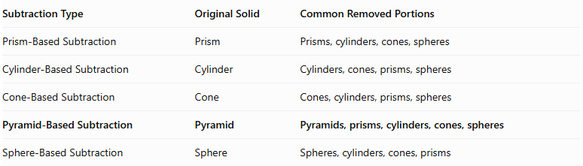
Subtraction Type | Original Solid | Common Removed Portions
Prism-Based Subtraction | Prism | Prisms, cylinders, cones, spheres
Cylinder-Based Subtraction | Cylinder | Cylinders, cones, prisms, spheres
Cone-Based Subtraction | Cone | Cones, cylinders, prisms, spheres
Pyramid-Based Subtraction | Pyramid | Pyramids, prisms, cylinders, cones, spheres
Sphere-Based Subtraction | Sphere | Spheres, cylinders, cones, prisms

Applications
# Source: AI Source: Provided by: [Data Path: Persons Table -> ID Column: 1, Name_En Column: Motasem Essam] -> From: [ChatGPT] on [7/25/2026]
- Mechanical Engineering: Designing tapered cavities, recessed structures, and specialized mechanical components.
- Manufacturing: Creating pyramid-shaped recesses, tapered openings, and cutout features.
- Architecture: Designing decorative pyramid structures, recessed surfaces, and architectural components.
- Construction: Producing hollow or modified pyramid-shaped structural elements.
- Product Design: Creating decorative objects and products with pyramidal cavities.
- CAD Modeling: Constructing complex three-dimensional objects using Boolean subtraction operations.
- Education: Teaching volume subtraction, surface area, and three-dimensional geometric transformations.

Key Points
# Source: AI Source: Provided by: [Data Path: Persons Table -> ID Column: 1, Name_En Column: Motasem Essam] -> From: [ChatGPT] on [7/25/2026]
- Pyramid-Based Subtraction removes one or more geometric portions from an original pyramid.
- The original pyramid can have different polygonal base shapes.
- Removed portions can be pyramids, prisms, cylinders, cones, spheres, or other solids.
- Subtraction can create holes, cavities, notches, grooves, slots, and depressions.
- Remaining volume equals original volume minus the removed volume, accounting for overlapping cutouts.
- Surface area must account for removed original surfaces and newly exposed surfaces.
- A blind hole ends inside the pyramid, while a through-hole passes completely through it.
- The position, dimensions, and shape of each cutout determine the final geometry.

Conclusion
# Source: AI Source: Provided by: [Data Path: Persons Table -> ID Column: 1, Name_En Column: Motasem Essam] -> From: [ChatGPT] on [7/25/2026]
Pyramid-Based Subtraction is a method of forming composite solids by removing one or more geometric portions from an original pyramid. It can produce simple cavities and holes as well as complex structures containing multiple cutouts and recessed regions.
Its mathematical analysis involves calculating the remaining volume and identifying all exposed surfaces after subtraction. It is an important concept in solid geometry, engineering, architecture, manufacturing, and three-dimensional modeling.

